Do Space Learn to Solder PCB Assembly Instructions

Document Version 1.0

Kevin Neubauer

Twitter: @kevinneubauer

https://hackaday.io/CircuitsNutsAndBolts

# Take Inventory

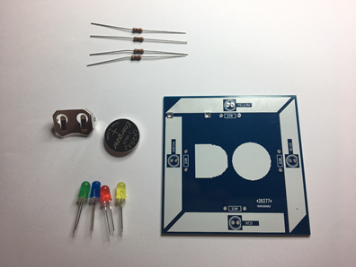

Each soldering kit should contain:

* 4 – 220 Ohm Resistors
* 1 – CR2032 Coin Cell Battery
* 1 – Coin Cell Battery Holder
* 1 – Green LED
* 1 – Blue LED
* 1 – Red LED
* 1 – Yellow LED
* 1 – Do Space Printed Circuit Board (PCB)

# Prepare Workspace

Ensure your workspace is clean of obstructions. Keep flammables away from the soldering iron.

Put on your safety glasses.

Plug in / turn on the soldering iron, set the temperature to 350 degrees, and place it in its stand.

# Resistors

Gently bend the wire leads on a resistor so that it looks like a U shape.

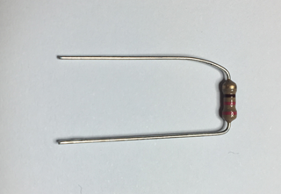

Insert the wire leads through the holes on either side of a rectangle marked with “220” on the PCB. The direction of the resistor does not matter.

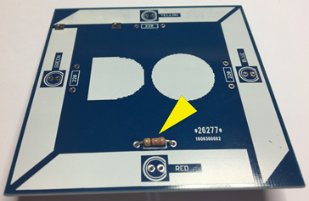

Turn the PCB over and bend the wires outward so that the resistor does not fall out.

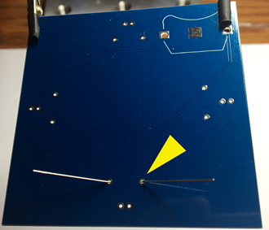

Take your soldering iron off its stand and clean the tip. Cleaning the tip is typically done on a wet sponge or brass sponge. You just want to make sure that there isn’t excess solder or other debris on the tip of the iron. Once the tip is clean, you want to tin it. Tinning the tip of the iron is done using just a bit of solder. Melt just a bit of solder on the tip of the iron so the tip is shiny. It is good practice to tin the tip of the iron any time its been sitting in its stand for a while or any time the tip appears dull. A clean, tinned tip conducts heat better.

Hold the iron in one hand and the solder in the other. Move the tip of the iron to your first solder joint, where the underside of the resistor wire lead meets the circuit board. Ensure the tip of the iron touches both the wire lead and the metal pad on the circuit board. You may need to angle the iron slightly to get good heat distribution.

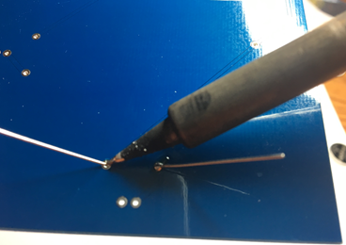

Hold the iron in place for a couple of seconds to heat up the joint. Move the solder into position with your other hand and touch the solder into the heated joint. It’s very important that the solder is melted by the heated joint, and not by the soldering iron. If the joint isn’t heated enough, the solder won’t flow into the joint and you will get a fragile or bad solder joint. Put just enough solder in to make what looks like a small mountain.

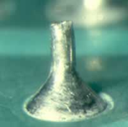

Give the first joint a second or two to cool down and repeat this process on the other side of the resistor. When both joints have cooled down, you can clip the excess wire from the wire leads on the underside of the circuit board. You will want to do this while holding the wire lead. Clipping these wire leads will often send bits of wire flying.

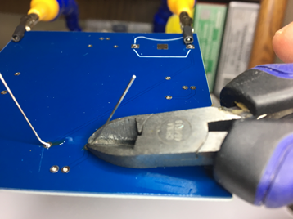

Repeat all of the above with each remaining resistor. After you are done, you should have 4 resistors soldered into your circuit board.

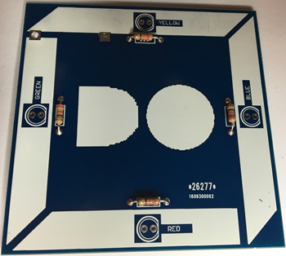

# LEDs

LEDs have a polarity to them. This means that they have a + pin and a – pin and that the direction of electricity flowing through them matters. Simply put, if you insert them into the circuit board the wrong way, they will not light up and may burn out.

There are typically two ways you can tell which side is + and which side is -. One way is by looking at the length of the pins. The longer pin is the + side.

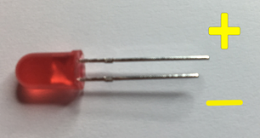

The other way is to look at the LED from the top down. Round LEDs usually, but not always, have a flat side. The flat side is the - side.

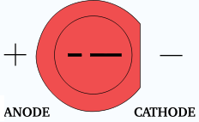

On a well designed circuit board, you will see indications of which way you need to insert the LEDs. You will either see + and/or – beside the holes or a graphic depicting the flat side of the LED. With this kit, the flat side is marked on the board. The shorter pin on the LED goes on the right side to match the flat side of the graphic

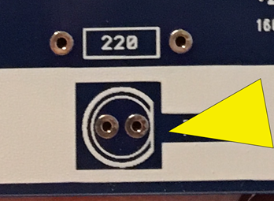

Pick any color LED and insert it into its holes with the shorter pin of the LED in the hole beside the flat part of the circle. Be sure to read the board. It will tell you what color LED goes in what holes. After the LED has been inserted, bend the pins slightly so it stays in the board when you flip it over.

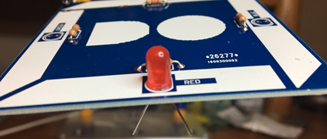

Flip the board over and solder the pins. Be sure to let each solder joint solidify before moving on to the next step. When both joints are soldered, clip the excess off the wire leads and repeat the process for the other LEDs. When you are done with all the LEDs, your board should look like this.

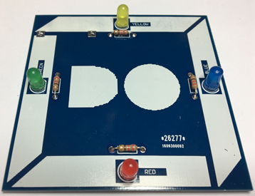

Flip the board over and melt a small mound of solder on the big square metal pad where the battery holder will go. Doing this ensures that the battery will make good contact with the board later on.

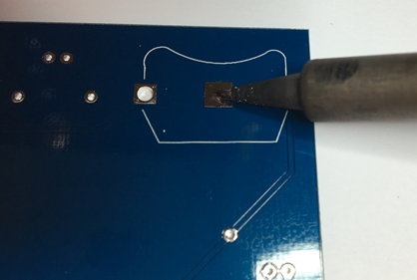

Insert the battery holder so that it matches the shape of the white outline on the board.

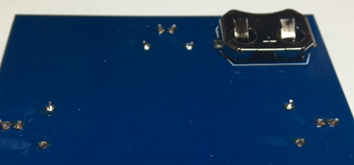

Flip the board over and solder the pins from the top side.

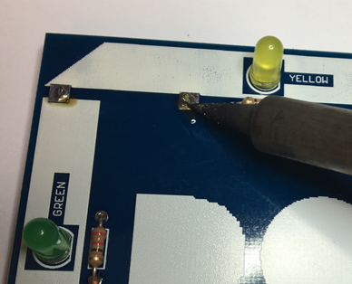

Test out your completed kit by inserting the coin cell battery with the + side of the battery matching the + sign on the battery holder. If all 4 LEDs light up, you are done! Unplug your soldering iron and let it cool down.